**Subspire**

**Team Maverick**

**Priya Gupta**

**Phani Sai Ram Munipalli**

**Piyush Mamidwar**

**Harsh Patel**

**Project Idea:**

Subspire is a Subscriptions Management Dashboard along with customized notifications from all kinds of services at one platform. It is hard for any normal individual user to keep track of their subscriptions or memberships and often forget that they are subscribed and being charged. So, we came up with a simple yet powerful solution of building a one-stop dashboard that stores your active plans, sending email notifications 5 days before your plan expiry date. You can stop worrying about missing out on any notifications while you are at work or spending time with family. All you need to do is just login to Subspire and get insights within seconds.

Subspire also values your personal data like email, name and phone number so we never collect those from people, and instead we just take the Zip Code. This is helpful to your community to contribute and understand what the best services in your neighborhood are. We envision Subspire as a B2B company in the future which can allow the service providers to understand where they stand in each location and who their competitors are.

**Tech Stack:**

Subspire is powered by AWS in every possible way to utilize its cloud services.

Frontend: React JS, Bootstrap5, HTML5, Tailwind CSS, Material UI

Backend: Node JS, MySQL (RDS)

AWS: Cognito, CodeStar, CodePipeline, Elastic BeanStalk, EC2, Multi-AZ, Auto Scaling Groups, Lambda, SES, Route 53

**Features:**

1. Beautiful UI
2. Signup & Verify email with Cognito service.
3. One-Stop dashboard where users can add new plans to track their active subscriptions.
4. Update current plans if there is any change at any point of the timeline.
5. Select whether you want to get notified or not.
6. Search based on Zip Code to see the top service providers in your area.

**Demo Screenshots:**

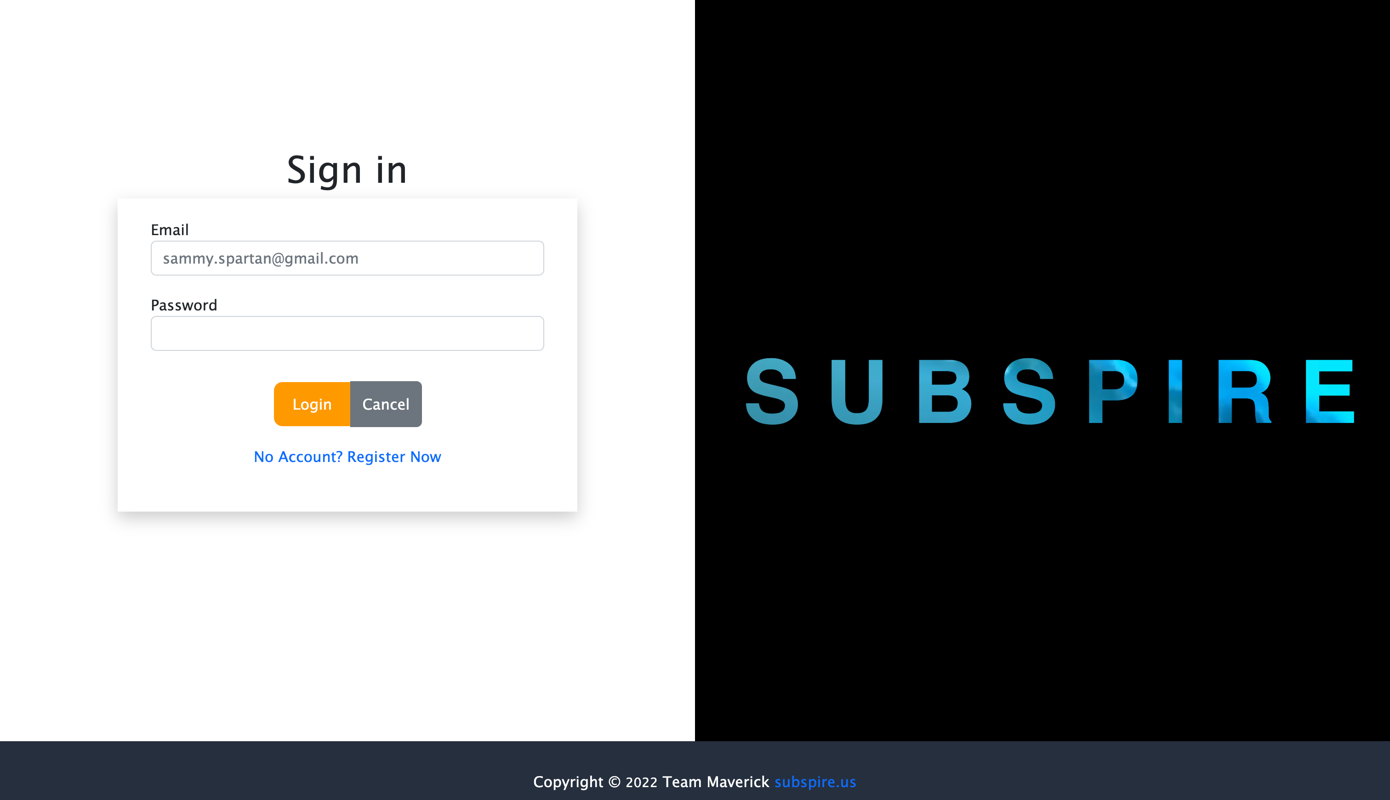

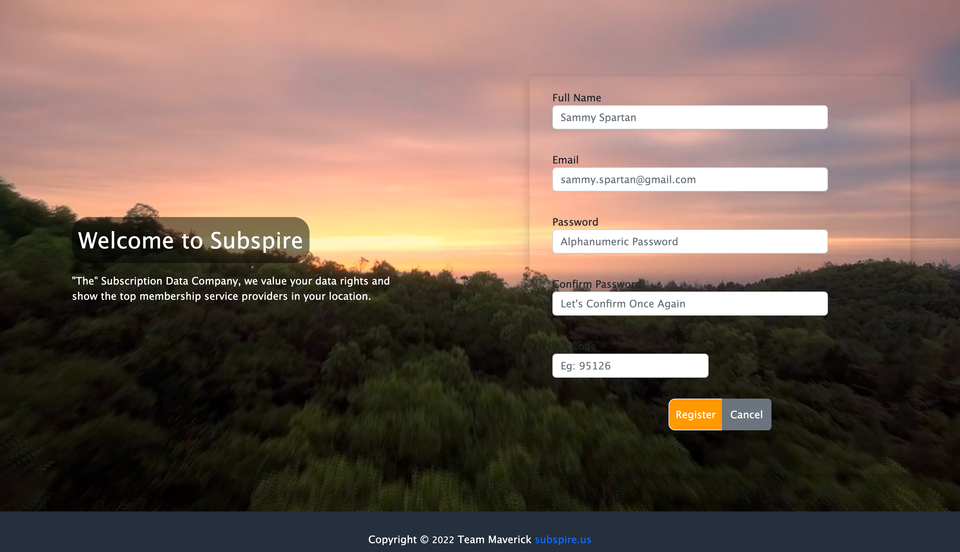

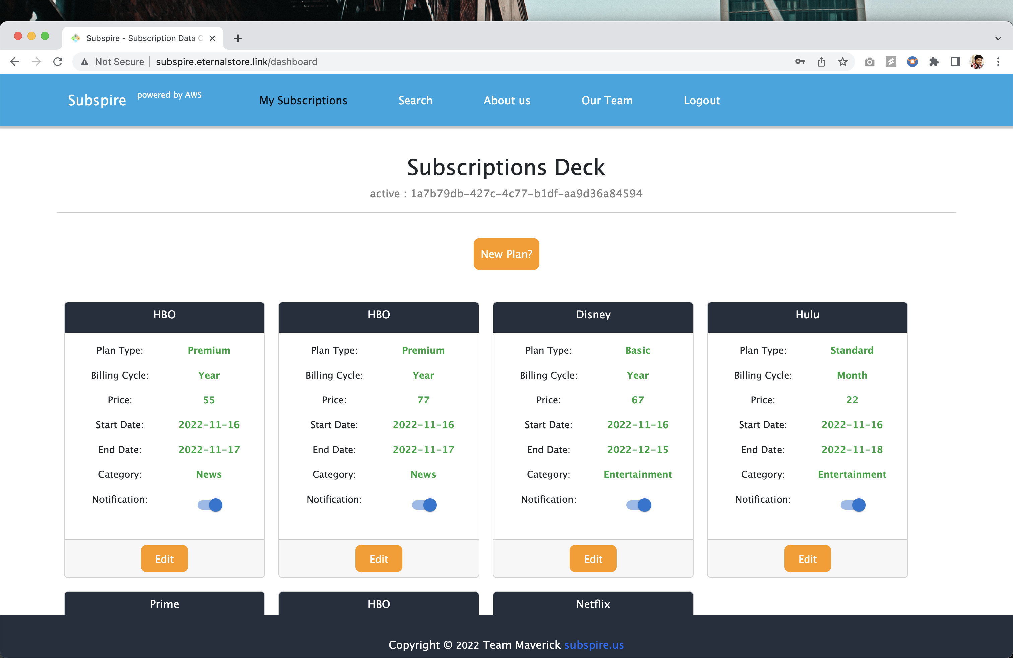

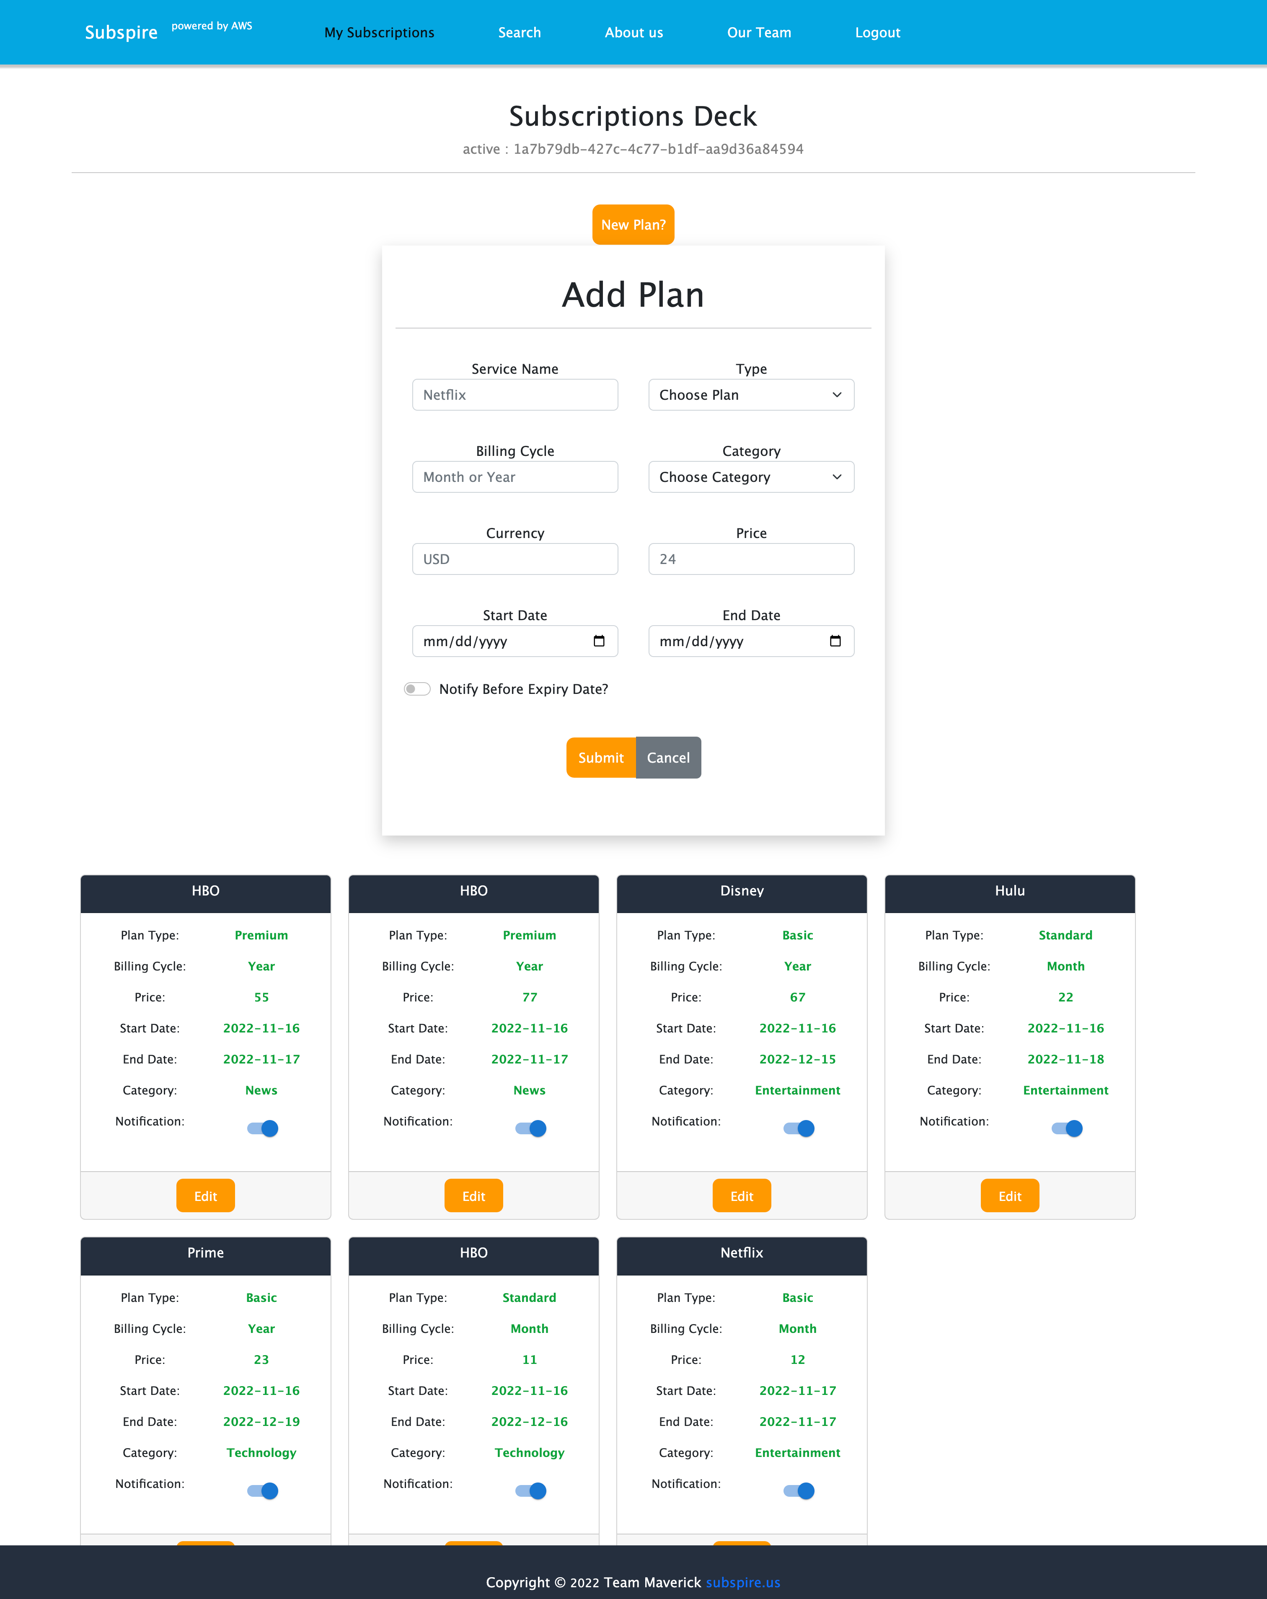

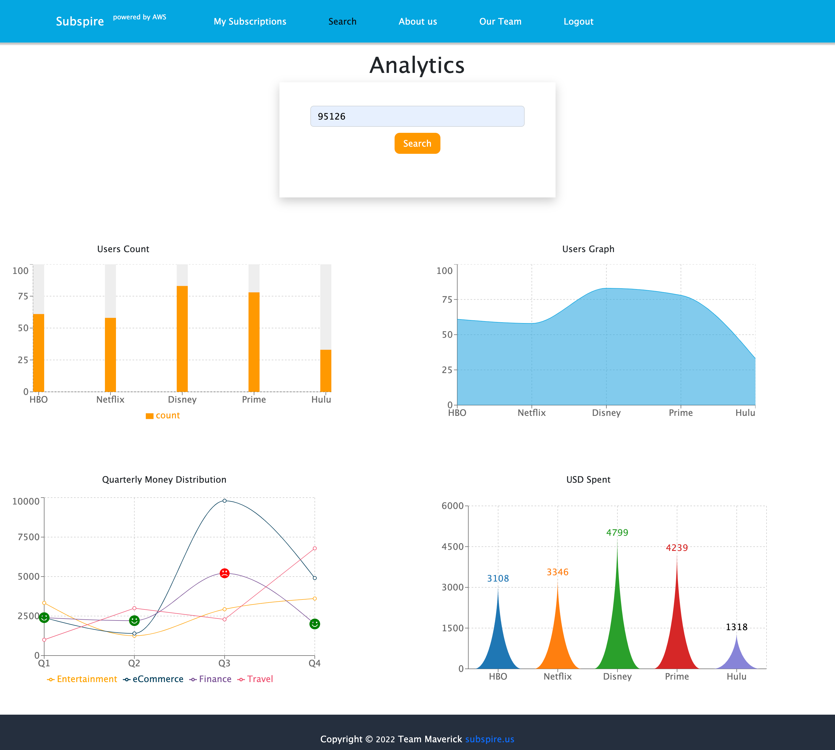

**Solutions:**

• Completely powered by AWS Services as a Global Cloud Solution - **Done**

• Authorized Sign in – **Done** – Used Cognito APIs and every API call is secured with Authorized Bearer Token

• Dashboard view of all your memberships and subscriptions at one place. -- **Done**

• Customize alerts for expiry dates as per your favorite time of day – Subspire sends email notifications to users 5 days before their plan’s expiry date. -- **Done**

• Understand your most used subscription for every 3 months based on Analytics. -- **Done –** Created mock data in AWS RDS to understand and bring out in different Charts on screen.

• We value your data rights and privacy. -- **Done –** we don’t store any of your personal information except your Zip Code and that is to provide you with best deals and services.

**Subspire URL:**

<http://subspire.eternalstore.link>

**Test Account:**

Email: phanicool4@gmail.com

Password: abc123456

**GitHub Links:**

Front End: <https://github.com/phanisaimunipalli/subspire-frontend>

Back End: <https://github.com/phanisaimunipalli/subspire-backend>

**Team’s Effort Distribution:**

Phani Sai Ram Munipalli:UX Design**,** UI Development, Micro-Frontends, Product Management

Priya Gupta: Designed Architecture, Implemented Cognito Services, Update API, Sign up API

Harsh Patel: Setup Amazon RDS, Script to Generate Mock Data, Created Cron Job, Login API

Piyush Mamidwar: Backend Owner, Lambda Function to integrate SES to send emails, Create Plan API

**CI/CD Pipeline:**

Used AWS CodeStar -> Code Pipeline -> CodeBuild for both frontend and backend services

